Embargo: Only to be published or disseminated at 1200 hour, Wednesday, September 24, 2025



MALAYSIAN ECONOMIC INDICATORS
LEADING, COINCIDENT & LAGGING INDEXES
JULY 2025

Malaysia’s economy is expected on a softened trajectory,
with the Leading Index recording 114.3 points in July 2025
PUTRAJAYA, September 24, 2025 – The annual growth rate of the Leading Index (LI) continued to moderate in July 2025 by recording a decline of 0.5 per cent to 114.3 points as compared to 114.9 points in the same month of the previous year (Exhibit I), as reported by the Department of Statistics Malaysia (DOSM). The detailed performance is published in the Malaysian Economic Indicators: Leading, Coincident & Lagging Indexes for July 2025 released today. The LI provides an early indication of turning points in the business cycle and the near-term direction of the economy.
Commenting further on the latest performance of the LI, Chief Statistician Malaysia, Dato’ Sri Dr. Mohd Uzir Mahidin said, “Double-digit declines in Real Imports of Other Basic Precious & Other Non-Ferrous Metals (-16.3%) and the Bursa Malaysia Industrial Index (-13.4%) influenced the softer performance. Conversely, the monthly performance rebounded to 0.5 per cent in July 2025, after recording negative
0.3 per cent in the previous month. This recovery was driven by strong performance in five out of seven components, particularly the Real Imports of Semi Conductors (0.5%)”.
Examining the smoothed long-term trend in July 2025, the LI remained below
100.0 points (Exhibit II). Nonetheless, Malaysia’s economy is poised for a moderate trajectory ahead. Stronger sectoral performance and steady internal demand will position the nation to navigate global challenges.
Meanwhile, the Coincident Index (CI), which measures the overall current economic performance, rose 2.2 per cent to 129.7 points in July 2025 as compared to
126.9 points in the same month of the previous year. This performance was supported by positive growth across all CI components, with the Real Contributions to the Employees Provident Fund (EPF) as the main contributor, recording 5.4 per cent.
At the same time, the monthly performance of the CI strengthened by 1.2 per cent, driven by the Industrial Production Index and Real Contributions to the EPF, both of which posted a 0.3 per cent increase.
ASEAN-Malaysia 2025 Chairmanship: The Department of Statistics Malaysia (DOSM) will chair the 15th ASEAN Community Statistical System Committee (ACSS15) which aims to strengthen the statistical cooperation towards sustainable regional development.
Malaysia, for the first time, ranked as number one (1) globally in the biennial Open Data Inventory (ODIN) 2024/25 report released by Open Data Watch (ODW), surpassing 197 other countries. This achievement marks a significant leap from its 67th position in the ODIN 2022/23 assessment.
The Government of Malaysia has declared October 20th as National Statistics Day (MyStats Day), with the theme 'Statistics is the Essence of Life'. Meanwhile, the Fourth World Statistics Day will be celebrated on 20th October 2025, with the theme ‘Driving Change with Quality Statistics and Data for Everyone’.
OpenDOSM NextGen is a medium that provides data catalogue and visualisations to facilitate users' analysis and can be accessed through https://open.dosm.gov.my.
Released by:

THE OFFICE OF CHIEF STATISTICIAN MALAYSIA DEPARTMENT OF STATISTICS MALAYSIA
24 SEPTEMBER 2025
APPENDIX I
Exhibit I: Leading Composite Index
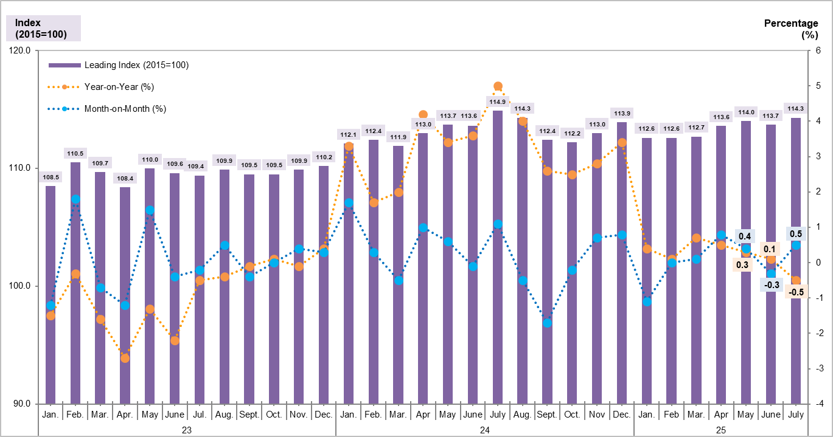

Exhibit II: Leading Composite Index (Long Term Trend = 100) and Business Cycle
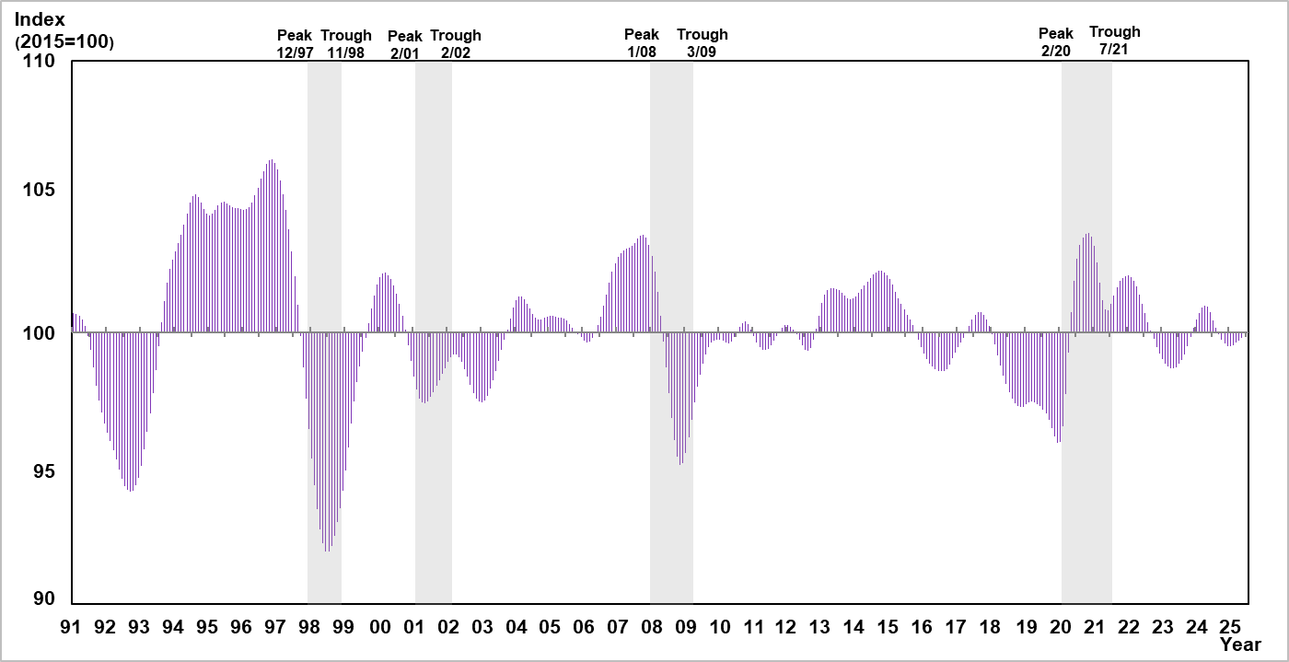
Exhibit III: Annual Changes of Leading Index Components
